**SERVERLESS IOT DATA PROCESSING**

# **INTRODUCTION**

In today's interconnected world, the Internet of Things (IoT) has transformed the way we collect, analyze, and utilize data. IoT devices, ranging from sensors and smart appliances to industrial machinery, generate an unprecedented volume of data, often in real-time. To efficiently harness this data and derive actionable insights, organizations are increasingly turning to serverless computing.

Serverless IoT data processing represents a paradigm shift in how we handle the deluge of information generated by IoT devices. Traditional server-based architectures often struggle to cope with the dynamic and scalable demands of IoT data streams. Serverless computing, on the other hand, provides an elegant and efficient solution to process and analyze this data in a way that is agile, cost-effective, and scalable.

At its core, serverless computing abstracts away the complexities of server management. Instead of provisioning and managing servers, developers can focus solely on the code that processes the data, leaving the infrastructure and scaling to the cloud provider. This approach is particularly well-suited for IoT data, which often arrives sporadically, unpredictably, and in vast quantities.

In this serverless IoT data processing era, functions or microservices are the building blocks of data processing pipelines. These functions can be triggered in response to specific events such as data arrival, ensuring that processing occurs precisely when needed. Whether it's monitoring environmental conditions, tracking the performance of industrial machinery, or managing smart homes, serverless IoT data processing allows organizations to act on data insights in near real-time.

This introductory guide will explore the key concepts, benefits, and best practices for implementing serverless IoT data processing. It will delve into the architecture, use cases, and tools that empower organizations to handle IoT data efficiently, enabling them to make informed decisions, automate actions, and pave the way for a smarter, more connected future.

# **OBJECTIVES**

*The objectives of serverless IoT data processing typically include:*

*1.* ***Scalability****: Serverless computing allows automatic scaling to handle varying data loads, ensuring that IoT data processing remains responsive and efficient.*

*2.* ***Cost Efficiency****: Serverless platforms charge based on actual usage, minimizing costs during periods of low activity in IoT systems.*

*3.* ***Simplified Management****: Serverless removes the need to manage infrastructure, allowing IoT developers to focus on code and application logic.*

*4.* ***Real-time Processing****: Serverless architectures can handle real-time data processing, enabling rapid decision-making in IoT applications.*

*5****. Event-Driven****: Serverless IoT data processing is event-driven, responding to data triggers and events as they occur.*

*6.* ***Security****: Serverless platforms often include security features, helping protect IoT data from unauthorized access and breaches.*

*7****. Low Latency****: Serverless can reduce latency in IoT data processing, making it suitable for applications where timely data is critical.*

*8.* ***Fault Tolerance****: Serverless platforms often have built-in fault tolerance mechanisms to ensure high availability of IoT systems.*

*9****. Flexibility****: Serverless allows IoT developers to choose and combine various services and functions to create tailored data processing pipelines.*

*10.* ***Integration****: Serverless platforms typically support integration with other cloud services, databases, and external systems, making it easier to build comprehensive IoT solutions.*

*Overall, serverless IoT data processing aims to provide a flexible, cost-effective, and efficient approach to managing and analyzing IoT data in real-time.*

# **PROBLEM DEFINITION**

The problem of serverless IoT data processing involves efficiently handling and analyzing the vast amounts of data generated by Internet of Things (IoT) devices without the need for traditional server infrastructure. Key challenges in this context include:

* **Scalability**: IoT generates massive volumes of data, and serverless solutions must be able to scale dynamically to accommodate variable workloads.

* **Real-time Processing**: Many IoT applications require real-time data processing and decision-making, necessitating low-latency serverless architectures.

* **Cost** **Management**: Serverless computing can help reduce infrastructure costs, but optimizing the costs associated with serverless functions, storage, and data transfer is crucial.

* **Data Ingestion**: Efficiently collecting data from diverse IoT devices and protocols while ensuring data integrity and security.

* **Data Transformation**: Processing and transforming raw IoT data into actionable insights, including filtering, aggregation, and enrichment.

* **Event Triggering**: Setting up event-driven workflows to respond to specific IoT events or anomalies in real time.

* **Data Storage**: Choosing the right storage solutions (e.g., NoSQL databases, object storage) for storing IoT data based on access patterns and retention requirements.

* **Security and Compliance**: Ensuring the confidentiality, integrity, and availability of IoT data, and compliance with relevant regulations (e.g., GDPR, HIPAA).

* **Monitoring and Debugging**: Implementing robust monitoring and debugging mechanisms for serverless functions and data pipelines.

* **Integration**: Integrating IoT data processing with other systems, applications, or cloud services for comprehensive IoT solutions.

Solving these challenges requires a well-architected serverless framework, appropriate tooling, and a deep understanding of both IoT domain-specific requirements and serverless technologies such as AWS Lambda, Azure Functions, or Google Cloud Functions.

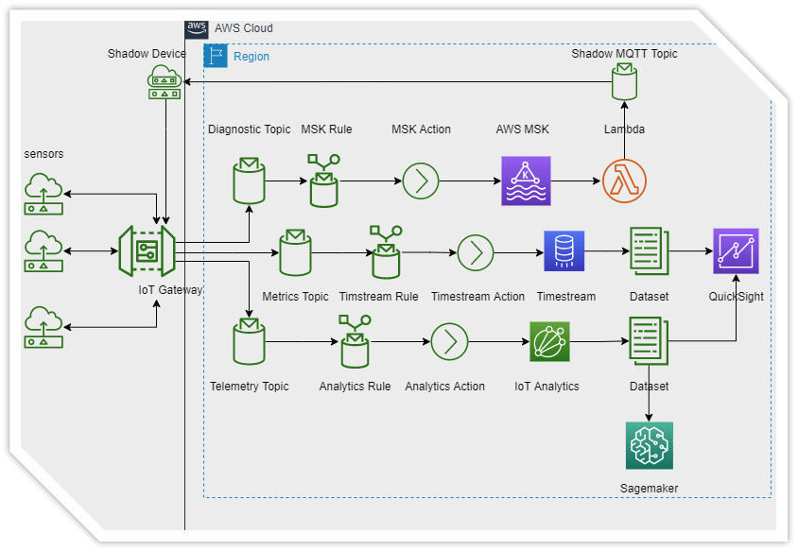

# **DESIGN THINKING**

*Design thinking is a user-centric approach to problem-solving that can be applied to serverless IoT data processing as follows:*

*1****. Empathize:***

*- Understand the needs of IoT stakeholders, such as end-users, operators, and developers.*

*- Identify pain points and challenges in IoT data processing.*

*2****. Define****:*

*- Clearly define the problem you’re trying to solve in IoT data processing.*

*- Set specific goals and objectives for your serverless architecture.*

*3****. Ideate****:*

*- Brainstorm serverless solutions for IoT data processing, considering scalability, latency, and cost-efficiency.*

*- Encourage creative thinking and consider various serverless technologies like AWS Lambda, Azure Functions, or Google Cloud Functions.*

*4****. Prototype****:*

*- Create a small-scale prototype of your serverless IoT data processing system.*

*- Test it with sample IoT data to ensure it meets the defined objectives.*

*5****. Test****:*

*- Collect feedback from stakeholders and refine your serverless prototype based on their input.*

*- Ensure that the IoT data processing system is robust, secure, and compliant with regulations.*

*6.* ***Implement****:*

*- Develop the full-scale serverless IoT data processing solution based on the refined prototype.*

*- Choose the appropriate serverless platform and programming languages for your use case.*

*7****. Iterate****:*

*- Continuously improve your IoT data processing system based on real-world usage and feedback.*

*- Monitor serverless functions for performance and reliability.*

*8.* ***Deploy:***

*- Deploy your serverless architecture for IoT data processing to a production environment.*

*- Implement automated scaling and monitoring to handle varying workloads.*

*9****. Evaluate****:*

*- Assess the effectiveness of your serverless solution in meeting the defined objectives.*

*- Gather data on its performance, cost savings, and user satisfaction.*

*10.* ***Refine****:*

*- Make necessary refinements to optimize serverless functions, improve data processing, and reduce costs.*

*- Consider future enhancements and innovations in serverless and IoT technologies.*

# **INNOVATION**

Certainly, serverless IoT data processing presents various challenges that can be addressed through innovation. Here are some ideas:

* **Real-time Data Analysis**: Develop serverless functions that can process IoT data in real-time. Use technologies like AWS Lambda, Azure Functions, or Google Cloud Functions to analyze incoming data streams for anomalies, trends, or critical events.

* **Auto-Scaling**: Implement auto-scaling mechanisms to handle varying data loads efficiently. Serverless platforms like AWS Lambda can automatically scale functions based on demand, reducing operational overhead.

* **Edge Computing:** Combine serverless with edge computing to process data closer to the source. This reduces latency and bandwidth requirements, making it suitable for applications requiring rapid response times.

* **Data Transformation**: Create serverless functions to transform raw IoT data into a structured format, making it easier to store and analyze. Tools like AWS Step Functions can help orchestrate data processing workflows.

* **Predictive Maintenance**: Use machine learning models within serverless functions to predict equipment failures. These predictions can trigger proactive maintenance, minimizing downtime.

* **Security and Authentication**: Innovate in security by implementing serverless-based authentication and authorization mechanisms to ensure that only authorized devices can send and receive IoT data.

* **Data Compression and Aggregation:** Develop serverless functions that compress and aggregate IoT data before storage or analysis. This reduces storage costs and speeds up processing.

* **Integration with Third-Party Services**: Leverage serverless functions to integrate IoT data with external services like weather APIs, social media platforms, or industry-specific data sources to gain deeper insights.

* **Serverless Databases**: Explore serverless database options like AWS DynamoDB or Azure Cosmos DB to store and retrieve IoT data efficiently without managing database infrastructure.

* **Cost Optimization**: Continuously monitor and optimize serverless function usage to minimize costs. Use tools like AWS Cost Explorer or Azure Cost Management for insights.

* **Data Retention Policies**: Implement policies for automatically archiving or deleting older IoT data to avoid storage cost overruns.

* **Monitoring and Alerting**: Develop serverless-based monitoring and alerting systems to proactively identify issues or anomalies in IoT data processing.

* **Blockchain Integration**: Consider using serverless to integrate blockchain technology for secure and immutable IoT data storage and verification.

* **Serverless** **Frameworks**: Explore serverless frameworks like Serverless Framework or AWS SAM to streamline development, deployment, and management of IoT data processing solutions.

* **Edge** **AI**: Combine serverless with edge AI capabilities to perform on-device analytics, reducing the need to transmit raw data to central servers.

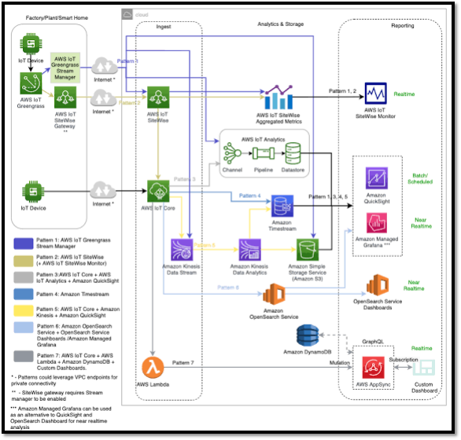

# **THE SERVERLESS IOT DATA PROCESSING SOLUTION USING IBM CLOUD FUNCTIONS AND DEVICE INTEGRATION**

*Creating a serverless IoT data processing solution using IBM Cloud Functions and device integration involves several steps:*

1. ***Set up IBM Cloud Functions****: First, you need to create an IBM Cloud account if you don’t have one. Then, set up the IBM Cloud Functions service. You can do this through the IBM Cloud Console.*

1. ***Device Integration****: Integrate your IoT devices with IBM Cloud IoT platform. This usually involves setting up device credentials and configuring the devices to send data to the platform.*

1. ***Data Ingestion****: Configure the IBM Cloud IoT platform to ingest data from your devices. This platform can handle data from various sources and devices.*

1. ***Create Cloud Functions****: You will create serverless functions that process the incoming IoT data. These functions can perform various tasks like data validation, transformation, storage, and trigger further actions.*
2. ***Data Processing****: In your Cloud Functions, process the IoT data as needed. You can use Node.js or Python, for example, to manipulate and analyze the data.*

1. ***Integration****: If you need to integrate with other services, databases, or external systems, you can do so within your Cloud Functions.*

1. ***Error Handling****: Implement error handling and logging to ensure the system is robust and can handle unexpected situations.*

1. ***Testing****: Thoroughly test your solution to ensure it works as expected, and that data processing, storage, and other functionalities are working properly.*

1. ***Monitoring and Scaling****: Implement monitoring and logging to keep track of the performance of your serverless functions. Set up auto-scaling to handle varying workloads efficiently.*

1. ***Security****: Ensure that your IoT data is transmitted and stored securely. IBM Cloud provides security features, and you should configure them appropriately.*

1. ***Cost Management****: Keep an eye on the cost of running your serverless functions. IBM Cloud Functions typically charges based on the number of executions and compute time.*

1. ***Documentation****: Document your solution thoroughly, including how to set it up, how to use it, and how to troubleshoot common issue.*

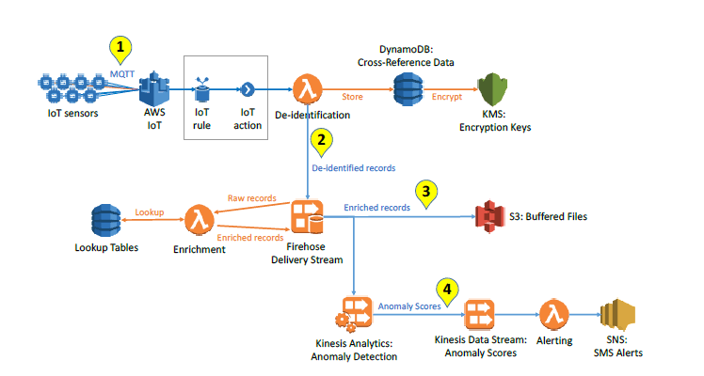

# **DATA PROCESSING USING IBM CLOUD**

To implement real-time data processing, automation, and storage using IBM Cloud Functions and IBM Cloud Object Storage, you can follow these steps:

1. **Setting up IBM Cloud Services**:

- If you haven't already, sign up for an IBM Cloud account and create a project.

- Set up the IBM Cloud Functions service and IBM Cloud Object Storage service within your project.

2. **Data Source Integration**:

- Identify the data source or sources that you want to process in real-time. This could be streaming data from IoT devices, logs, social media data, or any other source.

3. **Create IBM Cloud Functions Actions**:

- Write the serverless functions (actions) that will process your real-time data. These functions can be written in various programming languages, and they will be triggered automatically when data arrives. For example, you can create actions that analyze sentiment in social media data, process sensor data from IoT devices, or categorize log data.

4**. Set Up Triggers**:

- Define triggers for your IBM Cloud Functions. Triggers are events that will invoke your actions. Depending on your use case, you can use HTTP triggers, message queues, or event-driven triggers like those provided by IBM Cloud Event Streams or Apache Kafka.

5**. Automation**:

- Within your IBM Cloud Functions, you can implement automation logic. For instance, if your action detects an anomaly in the data, it can trigger another action to send an alert or perform corrective actions. These automations can be defined within your serverless functions.

6. **Data Processing and Transformation**:

- In your IBM Cloud Functions actions, perform data processing, transformation, and any necessary computations. You can use libraries, SDKs, and external services for specialized tasks like machine learning or natural language processing.

7. **Storage to IBM Cloud Object Storage**:

- Store the processed data in IBM Cloud Object Storage. Create containers or buckets to organize your data. You can use the IBM Cloud Object Storage SDK or API to upload the processed data from your IBM Cloud Functions actions to the storage.

8. **Data Retention Policies**:

- Define data retention policies and lifecycle rules within IBM Cloud Object Storage to manage the storage and archiving of your data over time.

9. **Data Analysis and Visualization**:

- To analyze and visualize the stored data, you can use various tools, including IBM Watson Studio, Jupyter Notebooks, or third-party analytics services. Connect your analysis tools to the data stored in IBM Cloud Object Storage.

10. **Monitoring and Logging**:

- Implement proper monitoring and logging for your IBM Cloud Functions. IBM Cloud provides services for logging and monitoring, such as IBM Cloud Monitoring with Sysdig and IBM Cloud Log Analysis, to help you keep track of the health and performance of your functions.

11. **Security and Access Control**:

- Ensure that your data and functions are secure. Implement access control and security measures to protect your data and functions from unauthorized access.

12. **Scaling and Optimization**:

- Depending on the volume of data and the processing requirements, scale your IBM Cloud Functions and storage resources to meet the demands of your application. Optimize your functions for performance and cost-efficiency.

13**. Testing and Deployment**:

- Thoroughly test your setup in a controlled environment before deploying it to a production setting.

14. **Documentation and Training**:

- Ensure that your team is well-trained on using IBM Cloud Functions and IBM Cloud Object Storage. Document your setup and configurations for future reference.

15. **Continuous Improvement**:

- Continuously monitor and improve your real-time data processing and automation system based on the performance and changing requirements of your application.

By following these steps, you can effectively implement real-time data processing, automation, and storage using IBM Cloud Functions and IBM Cloud Object Storage for analysis and decision-making in your application or system.

# **CONCLUSION**

*Throughout this design thinking process, it’s crucial to involve cross-functional teams, including IoT experts, cloud architects, and end-users, to ensure a well-rounded and user-friendly serverless IoT data processing solution.*

Innovating in these areas can help address challenges in serverless IoT data processing and create more efficient and scalable solutions. Keep in mind that the choice of serverless platform and technologies may vary depending on your specific use case and requirements.

In conclusion, serverless IoT data processing represents a transformative approach that empowers organizations to harness the full potential of IoT data. It streamlines data processing, enables real-time insights, and provides a cost-effective, scalable solution for the IoT era. With the ability to focus on code and leave infrastructure concerns to the cloud provider, businesses can unlock the full value of their IoT investments, driving innovation, automation, and decision-making in a data-driven world. As IoT continues to shape the future, serverless computing offers a compelling path forward for businesses seeking to stay ahead in this rapidly evolving landscape.